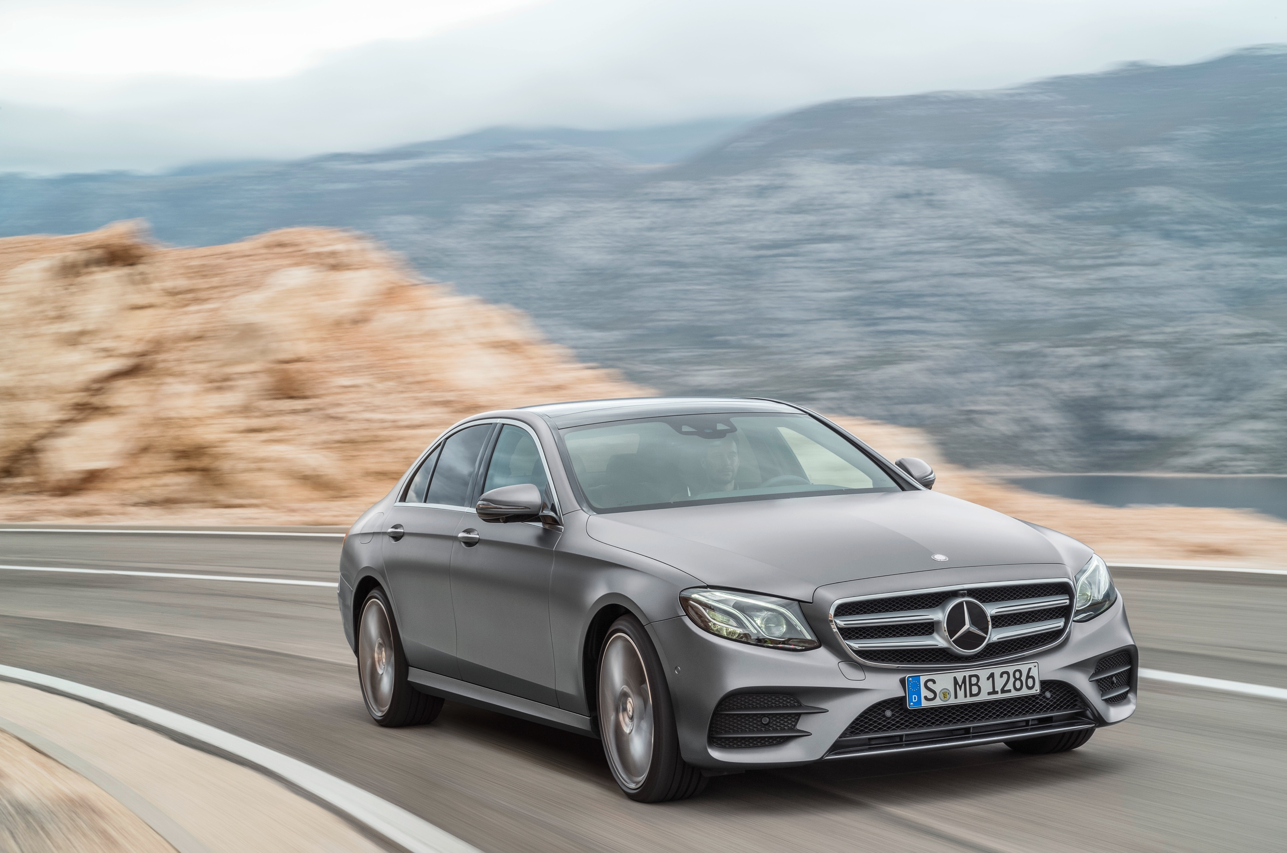
Overview of Mercedes-Benz Cars unit sales
 | August 2018 | Change in % | Jan-Aug. 2018 | Change in %
Mercedes-Benz | 155,918 | -8.5 | 1,512,268 | +1.1
smart | 8,470 | +9.8 | 85,534 | -2.6
Mercedes-Benz Cars | 164,388 | -7.7 | 1,597,802 | +0.9
Mercedes-Benz unit sales in the regions/markets
Europe | 54,989 | -10.7 | 597,347 | -3.9
- thereof Germany | 21,442 | -14.8 | 195,163 | -4.2
Asia-Pacific | 72,342 | -1.3 | 639,184 | +9.8
- thereof China | 53,295 | +5.5 | 446,075 | +13.9
NAFTA | 24,538 | -19.5 | 240,671 | -5.5
- thereof USA | 20,339 | -19.8 | 199,215 | -6.6

